My Book of the Rosary
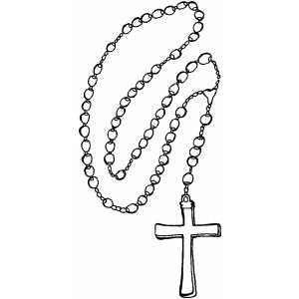

Name: _____________________________________
How To Pray the Rosary

Look at your rosary, what is it made up of?
________________________________________________
What shape is it in?
________________________________________________
How many groups are the beads divided into?
________________________________________________
How many beads are in each group?
________________________________________________
What are the two prayers that we pray mostly when we pray the rosary?
- __________________________________________
- __________________________________________

What else does the rosary have on it?
________________________________________________
What is this to remind us about?
________________________________________________
When can you pray the rosary?
________________________________________________

Prayers of the Rosary
Hail Mary:  Hail Mary, full of grace.  Our Lord is with you.  Blessed are you among women,  and blessed is the fruit of your womb,  Jesus.  Holy Mary, Mother of God,  pray for us sinners,  now and at the hour of our death.  Amen. | Our Father:  Our Father, Who art in heaven  Hallowed be Thy Name;  Thy kingdom come,  Thy will be done,  on earth as it is in heaven.  Give us this day our daily bread,  and forgive us our trespasses,  as we forgive those who trespass against us;  and lead us not into temptation,  but deliver us from evil. Amen.
Glory Be:  Glory be to the Father and to  the Son and to the Holy Spirit,  as it was in the beginning, is now  and ever shall be, world without end.  Amen | Creed:  I believe in God, the Father Almighty,  Creator of Heaven and Earth  And in Jesus Christ  His only Son, Our Lord  Who was conceived of the Holy Spirit  Born of the Virgin Mary  Suffered under Pontius Pilate  Was crucified, died and was buried.  On the third day, he rose again  He ascended into Heaven  and is seated at the right hand  of God, the Father Almighty.  He will come again to judge the living and the dead.  I believe in the Holy Spirit,  the Holy Catholic Church,  the Communion of Saints,  the forgiveness of sins,  the resurrection of the body,  and life everlasting.  Amen.
How To Pray the Rosary
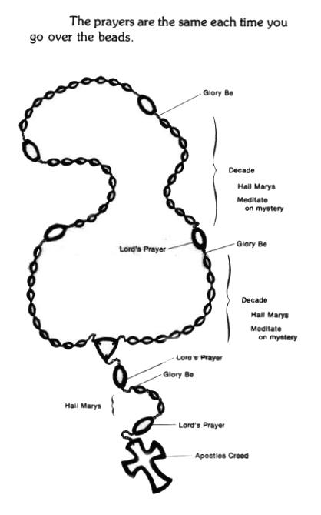
Mysteries of the Rosary
There are ___________ groups of Mysteries of the Rosary
They are:
_______________________________________________________________

_______________________________________________________________

_______________________________________________________________

_______________________________________________________________

Mysteries of the Rosary

The Joyful Mysteries:

1._____________________________________________________________

2._____________________________________________________________

3._____________________________________________________________

4._____________________________________________________________

5._____________________________________________________________

Mysteries of the Rosary

The Luminous Mysteries:

1._____________________________________________________________

2._____________________________________________________________

3._____________________________________________________________

4._____________________________________________________________

5._____________________________________________________________

Mysteries of the Rosary

The Sorrowful Mysteries:

1._____________________________________________________________

2._____________________________________________________________

3._____________________________________________________________

4._____________________________________________________________

5._____________________________________________________________

Mysteries of the Rosary

The Glorious Mysteries:

1._____________________________________________________________

2._____________________________________________________________

3._____________________________________________________________

4._____________________________________________________________

5._____________________________________________________________

History of the Rosary

